WRITING, SIMPLIFYING AND ORDERING FRACTIONS
Pearson Edexcel - Monday 8 June 2020 - Paper 3 (Calculator) Foundation Tier

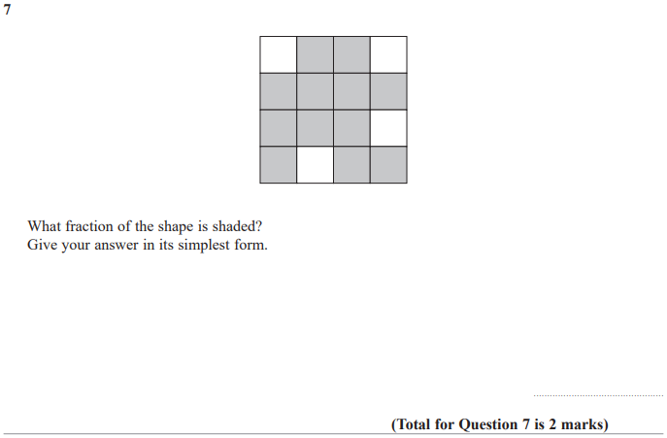

Pearson Edexcel - Thursday 24 May 2018 - Paper 1 (Non-Calculator) Foundation Tier

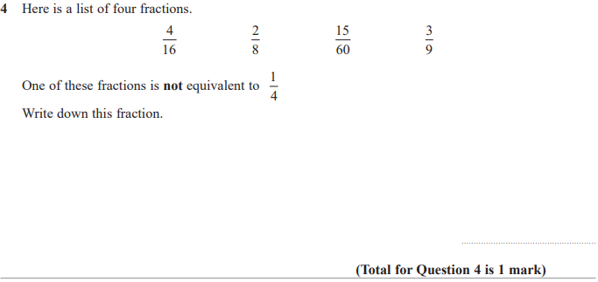

Pearson Edexcel – Specimen 1 - Paper 2 (Calculator) Foundation Tier
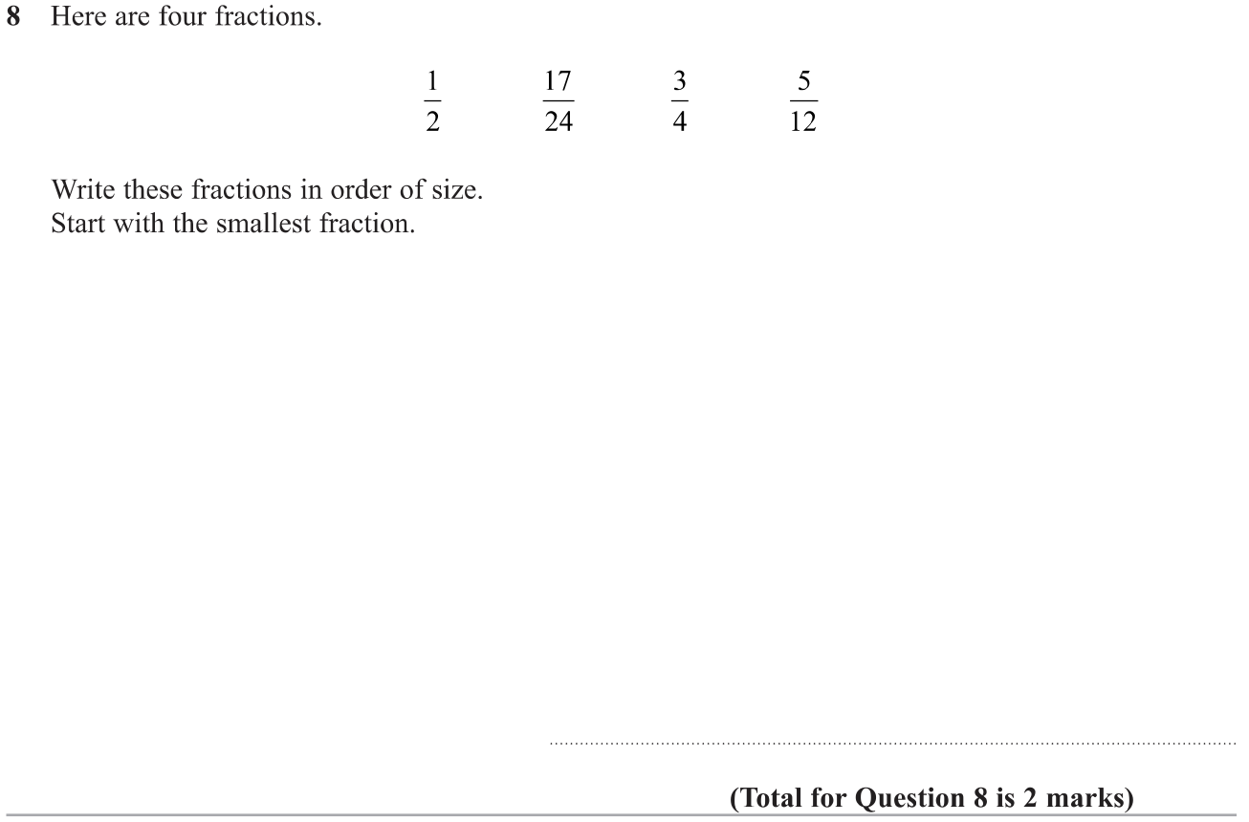

Pearson Edexcel – Sample Paper 1 (Non-Calculator) Foundation Tier

OCR Wednesday 8 November 2017– Morning (Calculator) Foundation Tier

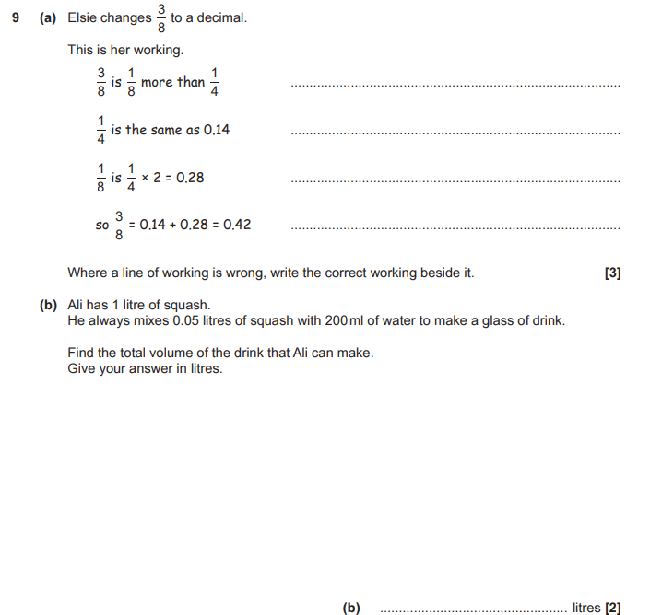

OCR Sample Question Paper 2 – Morning/Afternoon (Non - Calculator) Foundation Tier

AQA Thursday 11 June 2019 – Morning (Calculator) Foundation Tier

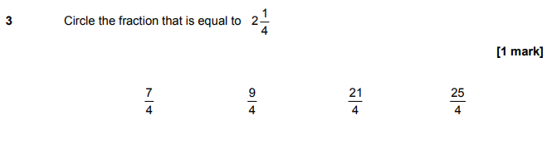

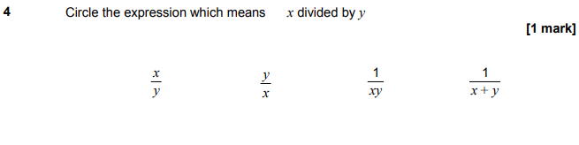

AQA Tuesday 6 November 2018 – Morning (Non-Calculator) Foundation Tier

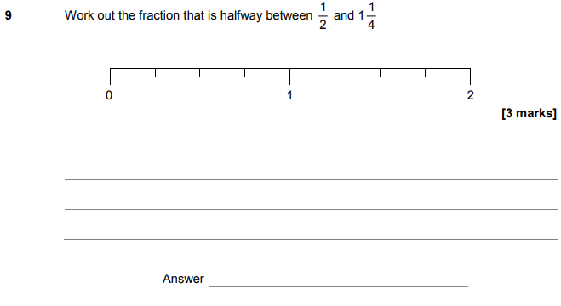

AQA Monday 12 November 2018 – Morning (Calculator) Foundation Tier

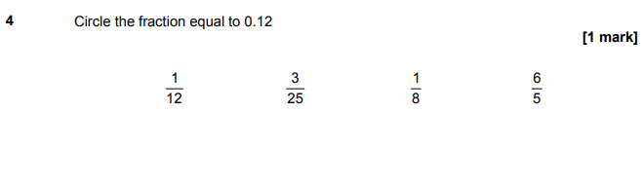
AQA Thursday 24 May 2018 – Morning (Non-Calculator) Foundation Tier

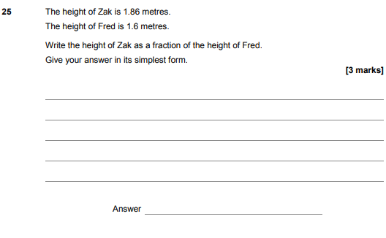

AQA Thursday 2 November 2017 – Morning (Non-Calculator) Foundation Tier

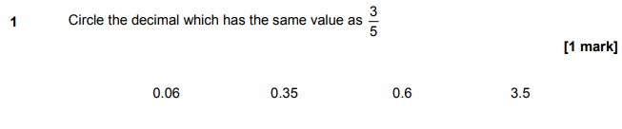
AQA Wednesday 8 November 2017 – Morning (Calculator) Foundation Tier

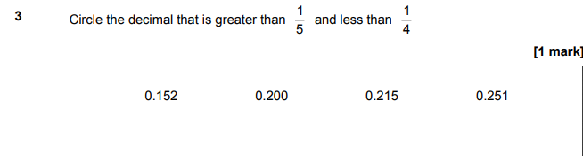
AQA Thursday 25 May 2017– Morning (Non-Calculator) Foundation Tier

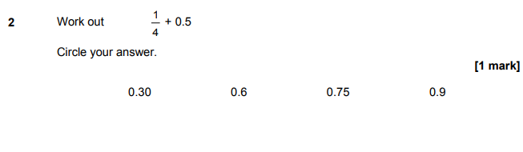

AQA Thursday 8 June 2017– Morning (Calculator) Foundation Tier

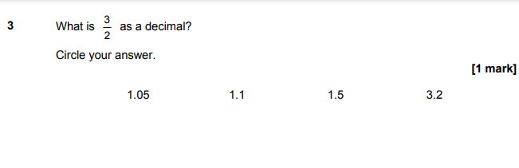
AQA Tuesday 13 June 2017 Morning– Morning (Calculator) Foundation Tier

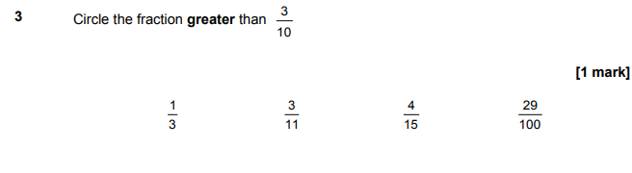

AQA Sample Paper 1– Morning (Non-Calculator) Foundation Tier

